Name_________________________________________________ Date________________ Period_________

Unit 1 Review

Example of Explicit Rule | Example of Recursive Rule

Linear Patterns | Exponential Patterns | Quadratic Patterns
Equation for: | Equation for: | Equation for:
Table for:  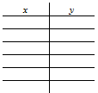 | Table for: | Table for:
Graph of:  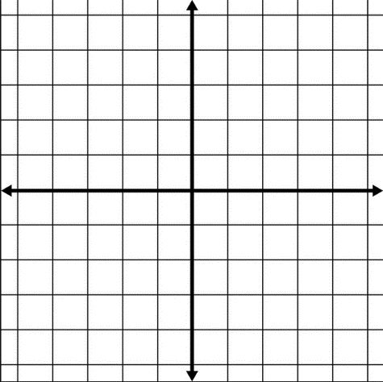 | Graph of:  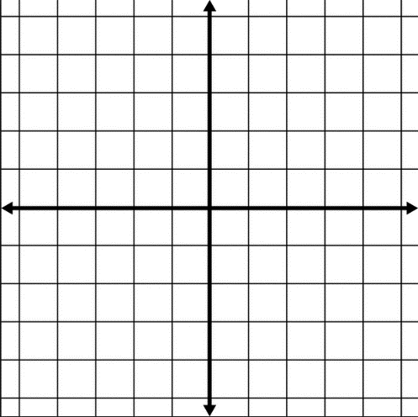 | Graph of:

Graphing Functions and Creating Tables

For each function make a table of at least 6 values, graph the function, and identify if it is linear, exponential, or quadratic.

Maximizing the size of a pen or corral with a fence

This problem is similar to MVP 1.4.

Bubba has 160 feet of fence and he wants to make the biggest possible rectangular corral for his horse.

- Sketch several possible rectangles that Bubba could make.

- Let the width of the corral be x. Fill in the table below and then sketch a graph of the values relating width and area.
Width of the corral (in feet) | Length of the corral (in feet) | Area of the corral (in feet²)

- Write both a recursive and explicit equation that models the area in terms of the width.

Domain and Range of a Function
Use appropriate symbols to denote the domain and range of the functions below.
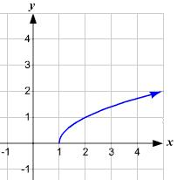
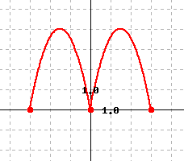
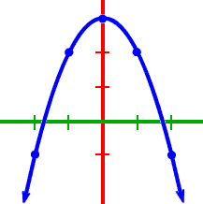
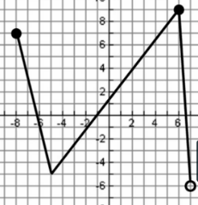

Domain: Domain: Domain: Domain: Domain:

Range: Range: Range: Range: Range:

Average Rate of Change of a Function
Finding the rate of change on a given interval, such as [2, 4] means use x = 2 and x = 4. Consider the two functions below. Find the rate of change over the intervals [0, 4] and [$-4, 0$].
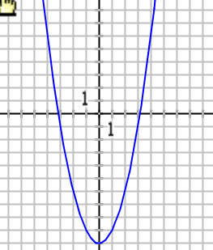
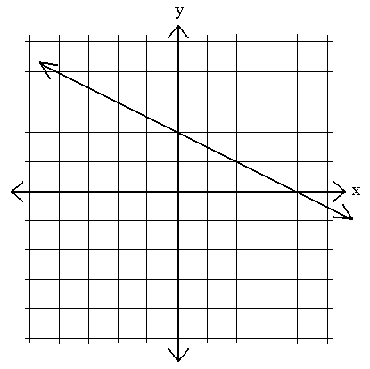

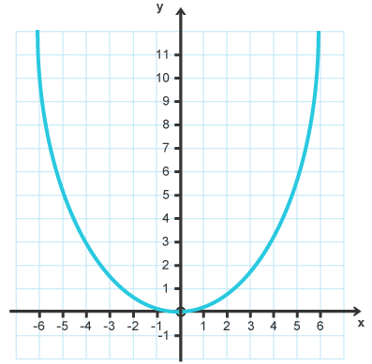
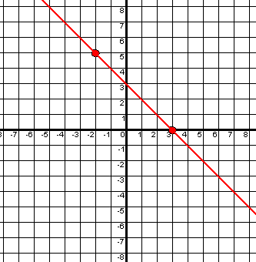

Falling Object Problem
A climber jumps from a climbing wall into a pool of water. The function that gives the height of the climber after t seconds is $h\left(t\right)=-16t^{2}+75.$

- Find h(0) and tell what it means.

- Find h(1), h(1.5), and h(2).

- When does the climber hit the water?

- Using h(t), find the average rate of change over the intervals [0, 1] and [1, 2].

- Sketch a graph of the problem.

Algebra Review
Distributive Property: Use the distributive property to simplify
$$2(3x+6)$$ | $$10(5m-5)$$ | $$2x(x+6)$$ | $$x^{2}(x-5)$$ | $$4m(-m-4)$$

Evaluating Functions: Evaluate each function at the point given
$$Find f\left(0\right)for$$  $$f\left(x\right)=x^{2}+3$$ | $$Find f\left(-1\right)for$$  $$f\left(x\right)=x^{2}-x$$ | $$Find f\left(2\right)for$$  $$f\left(x\right)=2x^{2}-x+2$$ | $$Find f\left(10\right)for$$  $$f\left(x\right)=2x(x-5)$$ | $$Find f\left(-5\right)for$$  $$f\left(x\right)=x^{3}-x^{2}-x$$

Adding and Subtracting Binomials: Add or subtract the binomials
$$\left(2x+3\right)+(4x+5)$$ | $$\left(2x^{2}+10x\right)-(2x^{2}-x)$$ | $$\left(16x+48\right)-(20x+50)$$ | $$\left(6x^{2}-10\right)+(-2x^{2}-2)$$

Multiply Binomials: Use the Distributive Property to multiply the binomials
$$\left(x+2\right)(x+3)$$ | $$\left(x+5\right)(x-5)$$ | $$\left(x^{2}+3\right)(x^{2}-4)$$ | $$2\left(x+10\right)(x-5)$$

Slope of a Line
Use the graphs to find the slope of the lines below.

Find the slope of a line given two points that are on that line.
Slope Formula

Given the two points, find the slope of the line that contains the points.
$$\left(10, 5\right), (6, 2)$$ | $$\left(-3, -3\right), (4, 2)$$ | $$\left(2, 2\right), (-4, -2)$$ | $$\left(5, 1\right), (2, -1)$$

Give the definetion and an example.
Continuous Function | Discrete Function

Finding the Area and Perimeter of Polygons (Adding and Multiplying Binomials)
Find the Area and Perimeter of each polygon.
$$x+3$$  $x$  Area:_____________ Perimeter: ______________ | $$(x+4)$$  $(2x+3)$  Area:_____________ Perimeter: ______________
$2x$  $x+3$  $x+2$  $6x$  Area:_____________ Perimeter: ______________ | $$2x^{2}+2x$$  $x^{2}$  Area:_____________ Perimeter: ______________

