Name___________________ period_____

Secondary II Unit 2 Chapter Practice Test

1) For each quadratic function, choose 5 x-values, plot the points and sketch the parabola. Make sure your points are graphed accurately. Label the vertex. Note: you may need to experiment with the x- values to get the ones that work the best.

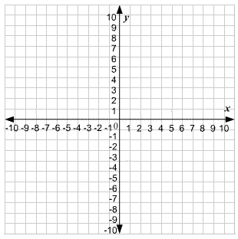
a) f(x) = (x – 3)² + 1

x | y

<-vertex here

b) f(x) = x² -6x + 9

x | y

<- vertex here

c) Sketch the axis of symmetry for each parabola. Give the equation for each axis of symmetry. a) x = _____ b) x = ______

Write each function in standard form if it is not already. Then identify a, b, and c.
2) y = -4x² – 5x + 4 a: b: c:
3) y = 7 + x + 8x² a: b: c:
4) -x² + 9 = y a: b: c:

Use the distributive property to change each quadratic equation to standard form. Then identify a, b, and c. You must show your work.

5) y = (x + 3)(3x – 1) 6) y = -4x(x + 5)

a: a:

b: b:

c: c:

7) Look at 2.1 problems 11-14. These are area models for quadratic expressions. Using these models to help you, sketch an area model for each of the following:

a) (2x)² b) (x+ 2)²

8) Find the value that completes the square, then write as a perfect square.

a) x² + 10x + _____ = ( )²

b) x² – 8x + _____ = ( )²

9) Use the table to identify the vertex and the equation for the axis of symmetry. Sketch a picture of the parabola clearly showing the vertex and the axis of symmetry.

Sketch the Graph below
x | y
-1 | -4
0 | 1
1 | 4
2 | 5
3 | 4
4 | 1

Vertex: _______ Axis of Symmetry x = _____

10) Use the table to identify the vertex and the equation for the axis of symmetry. Sketch a picture of the parabola clearly showing the vertex and the axis of symmetry.

Sketch the Graph below
x | y
-7 | 2
-5 | -4
-3 | -6
-1 | -4
1 | 2

Vertex: _______ Axis of Symmetry x = _____

