Name:________________ my group members____________________________________

Group work part I: Graphing quadratic functions Form B

a) Graph each quadratic function on the graphing calculator.
b) Sketch your graph and your partners’ graphs on your graph paper. Each graph should contain four quadratic functions (unless your group only has three people)
c) Identify which graph goes with each equation.
c) In each problem, the graph has been somehow changed from its original position/shape. Describe what is happening in each case.

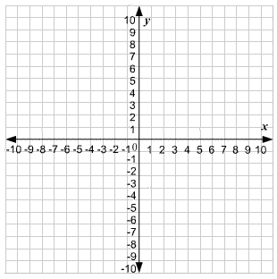
1) f(x) = x² + 5

After comparing graphs with my group, we have decided that this is what is happening to these
graphs:_______________________________
_____________________________________

2) f(x) = (x - 1)²
After comparing graphs with my group, we have decided that this is what is happening to these
graphs:_______________________________
_____________________________________

3) f(x) = 2x²

After comparing graphs with my group, we have decided that this is what is happening to these
graphs:_______________________________
____________________________________

4) f(x) = (1/3) x²

After comparing graphs with my group, we have decided that this is what is happening to these
graphs:________________________________
______________________________________

Graphs of quadratic functions are called parabolas. Parabolas always have a vertex. The vertex is easy to find. It is the ‘tip’ of the parabola. List the (x, y) coordinates for the vertex for each of your parabolas here:

#1:__________ #2:___________ #3:__________ #4___________
f(x) = a(x – h)² + k
When graphing quadratic functions, we use this form:

Discuss with your group what each value does to change the graph from its original shape or position.

How does k affect the graph? _______________________________________________
How does h affect the graph? _______________________________________________
How does a affect the graph? _______________________________________________
Group work part II : Quadratics and the distributive property
Use the distributive property to multiply each pair of binomials

a) (x + 4)(x + 1) b) (x + 4)(x - 10) c) (x – 5)(x – 1) d) (x – 7)(x + 7)

Group work part III: the fence problem from Unit one test

Several students had trouble with this problem, so we will review it again. You are given 60 feet of fence to build a rectangularfence against a river (or the side of a house). Building the fence against another object makes the problem a little simpler.
a) Sketch a picture to the right. Your fence is
rectangular.
b) How do you find the area of a rectangle?
rectangle area = _______________
c) In this problem, we let the width = x, and
let the length = 60-2x. Label your picture
with these variables.
d) What will be the area of this rectangle?
area = _______________________
Use the graph to the right to graph width
on the x-axis and area on the y- axis.

width | length | area
13
14
15
16
17

What are the dimensions, and area, of the largest rectangle?__________________________

